Tremont Parks & Recreation Center – 202 Registration Form

Parent Name ______________________ Email _____________________________
Address ___________________________ City ________________ Zip ___________
Home # _____________________ Cell # ________________ Work #_____________
22522 IL Route 9
Tremont, IL 61568
(309) 925-3811
www.tremontpark.org

Emergency Contact: __________________ Phone # _____________ Relationship ________
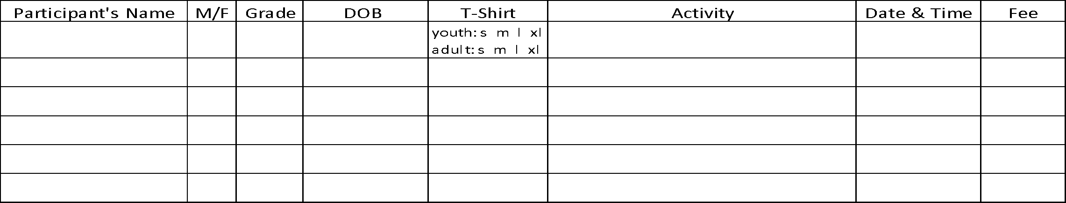
Are you interested in coaching or helping? Yes ______ No ______ circle shirt size: Adult S M L XL XXL
PAID: cash or check # ___________ Total fees: ________
*****ALERT***** Please list any allergies or special needs: ________________________________________

REGISTRATION POLICIES AND PROCEDURES
The Park District reserves the right to cancel, postpone, or combine classes and change instructors.
Programs not meeting the minimum registration one week prior to the start of class will be cancelled.
Cancellation decisions will in most cases be made one week in advance of the beginning of the program. All participants in cancelled classes will be notified by Park District Staff and will receive a full refund.
If minimum enrollment is met, registrations will continue to be accepted until the class is full.
Registration is not accepted by instructors. Please register at the park district office.
There is a $20 charge for checks returned for insufficient funds.
All fees must be paid at the time of registration. Participation in any TAPD program will not be allowed until all outstanding balance due to the park district are paid in full. If payment arrangements are needed, please call the TAPD office prior to registration.

WAIVER AND RELEASE - Read Over Carefully
Please read this form carefully and be aware in registering yourself, your child or ward for participation in this program you will be waiving and releasing all claims for injuries you or your minor child/ward might sustain arising out of this program. As a participant in the program or the parent/guardian of a participant in the program, I recognize and acknowledge that there are certain risks of physical injury and I agree to assume the full risk of any injuries, including death, damages or loss which I or my minor child/ward may sustain as a result of participating in any and all activities connected with or associated with such program. I agree to waive and relinquish all claims I or my minor child/ward may have as result of participating in the program against the Park District and its officers, agents, servants, and employees. I do hereby full release and discharge the Park District and its officers, agents, servants and employees from any and all claims from injuries, including death, damage or loss which I or my minor child/ward may have or which may accrue to me or my minor child/ward on account of my participation in the program. I further agree to indemnify and hold harmless and defend the Park District and its officers, agents, servants and employees from any and all claims resulting from injuries including death, damages and losses sustained by me or my minor child/ward and arising out of, connected with or in any way associated with the activities of the program. In case of accident or sickness, I consent to emergency medical care provided by ambulance or hospital personnel. I hereby consent to the use of my photograph in the Park District brochures, publications, slide presentations, etc. Participant will disclose any illness, fever or COVID symptoms or exposure and will refrain from participating if present.
I, for myself, spouse, child and other personal representatives assume the risk to have contact with individuals, who have been exposed to and/or have been diagnosed with one or more communicable diseases, including but not limited to COVID19 or other medical conditions diseases, or maladies does exist and it is impossible to eliminate the risk that I/we could be exposed to or become infected.
I have read and fully understand the above Registration Policies and Procedures and Waiver and Release of all Claims.

Signature of Parent/Guardian ________________________________________ Date ___________________

